CISC 7374 Digital Image Processing

Programming Project 3 Due: 02/19/2019

Professor : Mariofanna ( Fanny) Milanova, Ph.D.
Xiaoxu Na
Task 1:Implement an interactive tool that :
- Display an image and its spectrum
- Allows the spectrum to be edited by blanking out regions selected with the mouse.
- Displays the inverse Fourier transform of the spectrum, allowing the user to see the effects of their editing.
>Run the file proj3_fourier.py
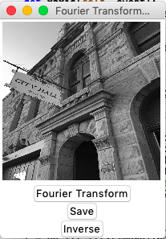
> Click “Fourier Transform” button, and the result will be displayed as below.
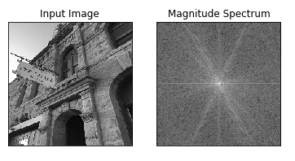
> Just simply draw a rectangle via mouse: click the mouse in any point on the popped canvas window and release the mouse to complete the rectangle.
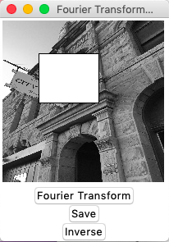
>After the rectangle is drawn, click the button “Save”, the message “Updated Image Saved” will show once it’s saved successfully.
> Click the button “Inverse” to check the inverse Fourier Transformation.
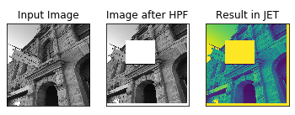

Task 2:Apply the mean operator
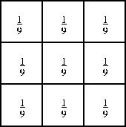
to

and compare its Fourier Transform before and after the operation.
>Run the file proj3_mean.py
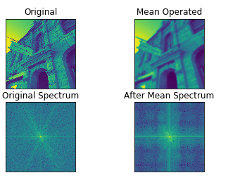

Task3:Add different sorts of noise to
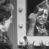
and compare the Fourier Transforms before and after the operation.
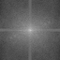
>Run the file proj3_noise.py

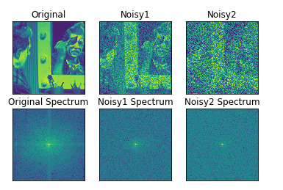

EXTRA CREDIT:
Task 4: Investigate if the Fourier Transform is distributive over multiplication. To do so, multiply

with
and take the Fourier Transform. Compare the result with the multiplication of the two direct Fourier Transforms
>Run the file proj3_multiplication.py

Fourier Transform is not distributive over multiplication.
